SEC Form 4

FORM 4

Check this box if no longer subject to Section 16. Form 4 or Form 5 obligations may continue. See Instruction 1(b).

UNITED STATES SECURITIES AND EXCHANGE COMMISSION
Washington, D.C. 20549
 |  | OMB APPROVAL
STATEMENT OF CHANGES IN BENEFICIAL OWNERSHIP
 |  | OMB Number: | 3235-0287
 |  | Estimated average burden
Filed pursuant to Section 16(a) of the Securities Exchange Act of 1934 |  | hours per response: | 0.5
or Section 30(h) of the Investment Company Act of 1940
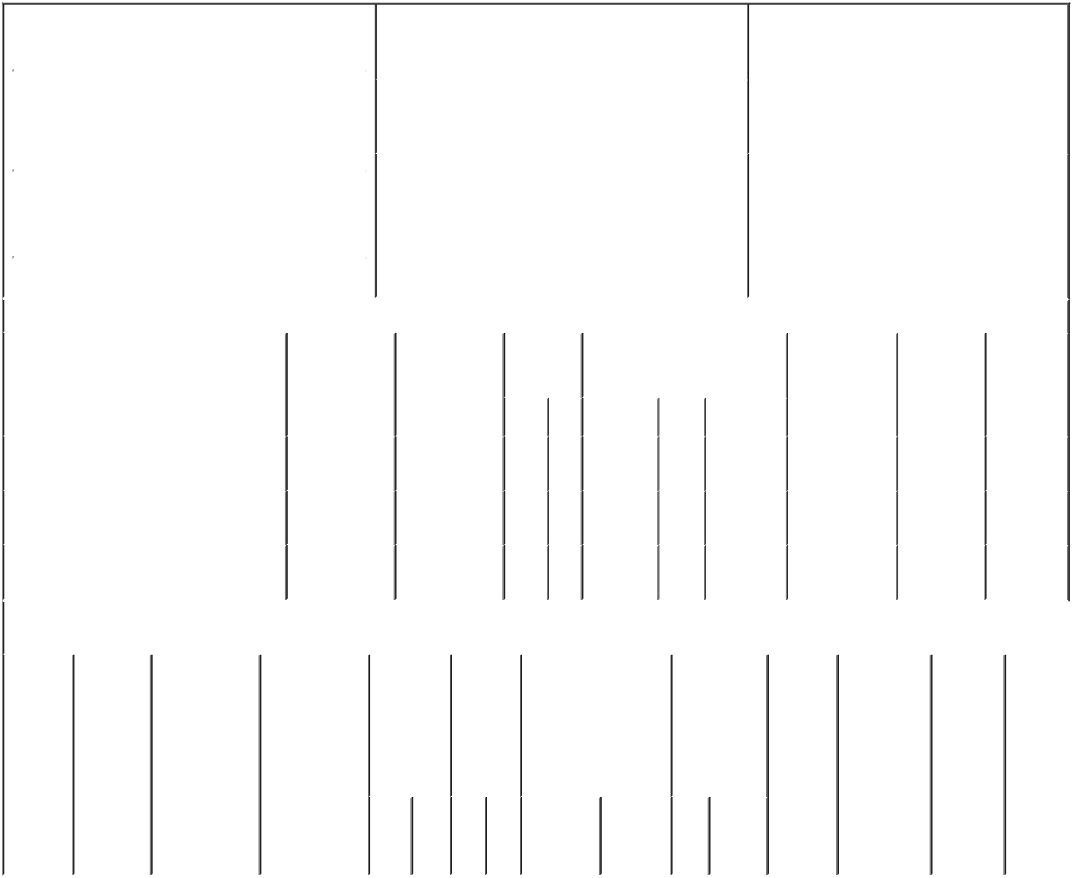

 | 1. Name and Address of Reporting Person* |  |  |  |  |  |  |  |  | 2. Issuer Name and Ticker or Trading Symbol |  |  |  |  |  |  |  |  | 5. Relationship of Reporting Person(s) to Issuer
 |  | HAGEDORN SUSAN |  |  |  |  |  |  |  | SCOTTS MIRACLE-GRO CO [ SMG ] |  |  |  |  |  |  |  |  | (Check all applicable)
 |  |  |  |  |  |  |  |  |  |  |  |  |  |  |  |  |  |  |  |  |  | Director |  |  | X 10% Owner
 |  |  |  |  |  |  |  |  |  |  |  |  |  |  |  |  |  |  |  |  |  | Officer (give title |  |  | Other (specify
 |  | (Last) | (First) |  |  | (Middle) |  |  |  | 3. Date of Earliest Transaction (Month/Day/Year) |  |  |  |  |  |  |  |  |  |  |  | below) |  |  | below)
 |  | C/O HAGEDORN PARTNERSHIP, L.P. |  |  |  |  |  |  | 05/10/2021
 |  | 800 PORT WASHINGTON BOULEVARD
 |  |  |  |  |  |  |  |  |  | 4. If Amendment, Date of Original Filed (Month/Day/Year) |  |  |  |  |  |  |  |  | 6. Individual or Joint/Group Filing (Check Applicable
 | (Street) |  |  |  |  |  |  |  |  |  |  |  |  |  |  |  |  |  | Line)
 |  |  |  |  |  |  |  |  |  |  |  |  |  |  |  |  |  |  |  |  | X Form filed by One Reporting Person
 |  | PORT
 |  | WASHINGTON ^{NY} |  |  |  | 11050 |  |  |  |  |  |  |  |  |  |  |  |  |  |  |  | Form filed by More than One Reporting
 |  |  |  |  |  |  |  |  |  |  |  |  |  |  |  |  |  |  |  |  |  | Person
 |  | (City) | (State) |  |  | (Zip)
 |  |  |  |  | Table I - Non-Derivative Securities Acquired, Disposed of, or Beneficially Owned
 | 1. Title of Security (Instr. 3) |  |  |  |  | 2. Transaction |  |  |  | 2A. Deemed |  |  | 3. |  | 4. Securities Acquired (A) or |  |  |  |  |  |  | 5. Amount of |  | 6. Ownership |  | 7. Nature of
 |  |  |  |  |  | Date |  |  |  | Execution Date, |  |  | Transaction |  | Disposed Of (D) (Instr. 3, 4 and 5) |  |  |  |  |  |  | Securities |  | Form: Direct |  | Indirect
 |  |  |  |  |  | (Month/Day/Year) if any |  |  |  |  |  |  | Code (Instr. |  |  |  |  |  |  |  |  | Beneficially |  | (D) or |  | Beneficial
 |  |  |  |  |  |  |  |  |  | (Month/Day/Year) |  |  | 8) |  |  |  |  |  |  |  |  | Owned Following |  | Indirect (I) |  | Ownership
 |  |  |  |  |  |  |  |  |  |  |  |  |  |  |  |  |  |  |  |  |  | Reported |  | (Instr. 4) |  | (Instr. 4)
 |  |  |  |  |  |  |  |  |  |  |  |  | Code V |  | Amount |  | (A) or | Price |  |  |  | Transaction(s)
 |  |  |  |  |  |  |  |  |  |  |  |  |  |  |  |  | (D) |  |  |  |  | (Instr. 3 and 4)
 | Common Shares |  |  |  |  | 05/10/2021 |  |  |  |  |  |  |  | S | 731.8 |  | D | $242.75⁽¹⁾ |  |  |  | 1,090,568 |  |  | I | See
 |  |  |  |  |  |  |  |  |  |  |  |  |  |  |  |  |  |  |  |  |  |  |  |  |  | footnote⁽⁴⁾
 | Common Shares |  |  |  |  | 05/10/2021 |  |  |  |  |  |  |  | S | 523 |  | D | $243.89⁽²⁾ |  |  |  | 1,090,045 |  |  | I | See
 |  |  |  |  |  |  |  |  |  |  |  |  |  |  |  |  |  |  |  |  |  |  |  |  |  | footnote⁽⁴⁾
 | Common Shares |  |  |  |  | 05/10/2021 |  |  |  |  |  |  |  | S | 131.1 |  | D | $245.26⁽³⁾ |  |  |  | 1,089,915 |  |  | I | See
 |  |  |  |  |  |  |  |  |  |  |  |  |  |  |  |  |  |  |  |  |  |  |  |  |  | footnote⁽⁴⁾
 |  |  |  |  |  | Table II - Derivative Securities Acquired, Disposed of, or Beneficially Owned
 |  |  |  |  |  | (e.g., puts, calls, warrants, options, convertible securities)
 | 1. Title of |  | 2. | 3. Transaction |  | 3A. Deemed |  |  | 4. |  | 5. Number |  |  | 6. Date Exercisable and |  |  | 7. Title and |  |  |  | 8. Price of |  | 9. Number of |  | 10. |  | 11. Nature
 | Derivative |  | Conversion | Date |  | Execution Date, |  |  | Transaction |  | of |  |  | Expiration Date |  |  | Amount of |  |  |  | Derivative |  | derivative |  | Ownership |  | of Indirect
 | Security |  | or Exercise | (Month/Day/Year) if any |  |  |  |  | Code (Instr. |  | Derivative |  |  | (Month/Day/Year) |  |  | Securities |  |  |  | Security |  | Securities |  | Form: |  | Beneficial
 | (Instr. 3) |  | Price of |  |  | (Month/Day/Year) |  |  | 8) |  | Securities |  |  |  |  |  | Underlying |  |  |  | (Instr. 5) |  | Beneficially |  | Direct (D) |  | Ownership
 |  |  | Derivative |  |  |  |  |  |  |  | Acquired |  |  |  |  |  | Derivative |  |  |  |  |  | Owned |  | or Indirect |  | (Instr. 4)
 |  |  | Security |  |  |  |  |  |  |  | (A) or |  |  |  |  |  | Security (Instr. |  |  |  |  |  | Following |  | (I) (Instr. 4)
 |  |  |  |  |  |  |  |  |  |  | Disposed |  |  |  |  |  | 3 and 4) |  |  |  |  |  | Reported
 |  |  |  |  |  |  |  |  |  |  | of (D) |  |  |  |  |  |  |  |  |  |  |  | Transaction(s)
 |  |  |  |  |  |  |  |  |  |  | (Instr. 3, 4 |  |  |  |  |  |  |  |  |  |  |  | (Instr. 4)
 |  |  |  |  |  |  |  |  |  |  | and 5)
 |  |  |  |  |  |  |  |  |  |  |  |  |  |  |  |  |  | Amount
 |  |  |  |  |  |  |  |  |  |  |  |  |  |  |  |  |  | or
 |  |  |  |  |  |  |  |  |  |  |  |  |  |  |  |  |  | Number
 |  |  |  |  |  |  |  |  |  |  |  |  |  | Date | Expiration |  |  | of
 |  |  |  |  |  |  |  |  | Code V |  | (A) (D) |  |  | Exercisable Date |  |  | Title | Shares

Explanation of Responses:

- The transaction was executed in multiple trades at prices ranging from $242.15 to $243.15. The price above reflects the weighted average sales price. Detailed information regarding the number of shares sold at each separate price will be provided upon request by the Commission staff, the Issuer or a security holder of the Issuer.

- The transaction was executed in multiple trades at prices ranging from $243.19 to $243.55. The price above reflects the weighted average sales price. Detailed information regarding the number of shares sold at each separate price will be provided upon request by the Commission staff, the Issuer or a security holder of the Issuer.

- The transaction was executed in multiple trades at prices ranging from $244.71 to $245.71. The price above reflects the weighted average sales price. Detailed information regarding the number of shares sold at each separate price will be provided upon request by the Commission staff, the Issuer or a security holder of the Issuer.

- The common shares are directly held by the Hagedorn Partnership, L.P. (the "Partnership"). The Reporting Person is a general partner of the Partnership. The amount of shares reported as beneficially owned represent the aggregate proportionate interest in common shares held by the Partnership of the Reporting Person. The Reporting Person disclaims beneficial ownership of the common shares except to the extent of his pecuniary interest.
/s/ Rob McMahon - Attorney- _{05/12/2021}
in-Fact

** Signature of Reporting Person Date

Reminder: Report on a separate line for each class of securities beneficially owned directly or indirectly.

* If the form is filed by more than one reporting person, see Instruction 4 (b)(v).

- Intentional misstatements or omissions of facts constitute Federal Criminal Violations See 18 U.S.C. 1001 and 15 U.S.C. 78ff(a). Note: File three copies of this Form, one of which must be manually signed. If space is insufficient, see Instruction 6 for procedure.
Persons who respond to the collection of information contained in this form are not required to respond unless the form displays a currently valid OMB Number.

