SEC Form 4

FORM 4

Check this box if no longer subject to Section 16. Form 4 or Form 5 obligations may continue. See Instruction 1(b).

UNITED STATES SECURITIES AND EXCHANGE COMMISSION
Washington, D.C. 20549
 |  | OMB APPROVAL
STATEMENT OF CHANGES IN BENEFICIAL OWNERSHIP
 |  | OMB Number: | 3235-0287
 |  | Estimated average burden
Filed pursuant to Section 16(a) of the Securities Exchange Act of 1934 |  | hours per response: | 0.5
or Section 30(h) of the Investment Company Act of 1940
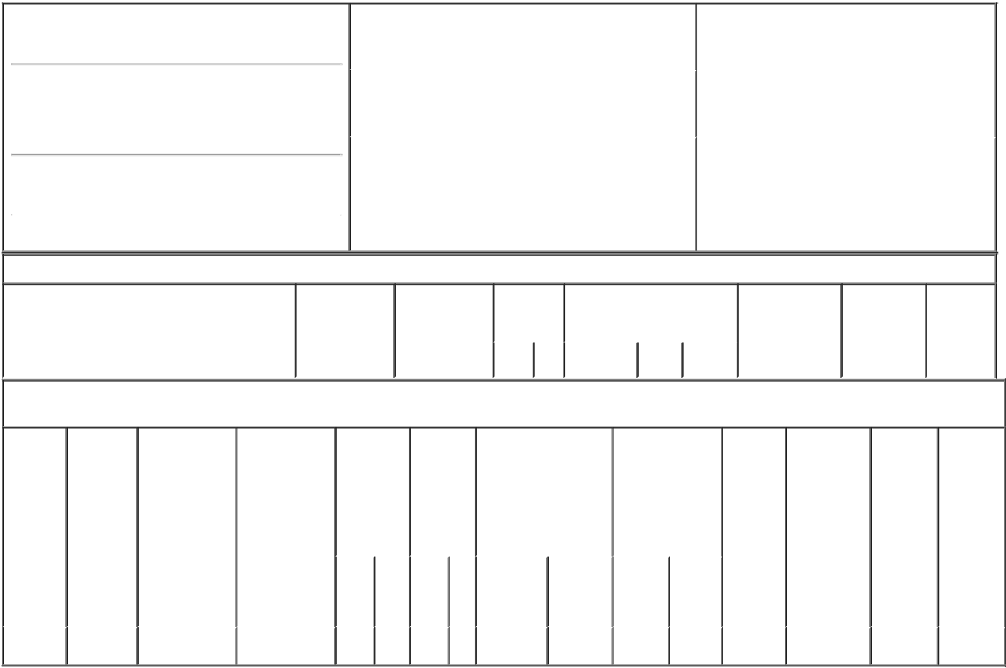

1. Name and Address of Reporting Person*
King James D

(Last) (First) (Middle)

C/O THE SCOTTS MIRACLE-GRO COMPANY 14111 SCOTTSLAWN ROAD

(Street)
 | MARYSVILLE | OH | 43041
 | (City) | (State) | (Zip)

2. |  | Issuer Name and Ticker or Trading Symbol |  | 5. Relationship of Reporting Person(s) to Issuer
 | SCOTTS MIRACLE-GRO CO [ SMG ] |  |  | (Check all applicable)
 |  |  |  |  | Director | 10% Owner
 |  |  |  | X | Officer (give title | Other (specify
3. |  | Date of Earliest Transaction (Month/Day/Year) |  |  | below) | below)
 |  |  |  |  | EVP and CCO
09/10/2021
4. |  | If Amendment, Date of Original Filed (Month/Day/Year) |  | 6. Individual or Joint/Group Filing (Check Applicable
Line)
X Form filed by One Reporting Person

Form filed by More than One Reporting
Person

Table I - Non-Derivative Securities Acquired, Disposed of, or Beneficially Owned

1. Title of Security (Instr. 3) | 2. Transaction | 2A. Deemed | 3. | 4. Securities Acquired (A) or |  |  | 5. Amount of | 6. Ownership | 7. Nature
 | Date | Execution Date, | Transaction | Disposed Of (D) (Instr. 3, 4 and |  |  | Securities | Form: Direct | of Indirect
 | (Month/Day/Year) | if any | Code (Instr. | 5) |  |  | Beneficially | (D) or Indirect | Beneficial
 |  | (Month/Day/Year) | 8) |  |  |  | Owned Following | (I) (Instr. 4) | Ownership
 |  |  |  |  |  |  | Reported |  | (Instr. 4)
 |  |  | Code V | Amount | (A) or | Price | Transaction(s)
 |  |  |  |  | (D) |  | (Instr. 3 and 4)

Table II - Derivative Securities Acquired, Disposed of, or Beneficially Owned

(e.g., puts, calls, warrants, options, convertible securities)

1. Title of | 2. | 3. Transaction | 3A. Deemed | 4. | 5. Number |  | 6. Date Exercisable and |  | 7. Title and |  | 8. Price of | 9. Number of | 10. | 11. Nature
Derivative | Conversion | Date | Execution Date, | Transaction | of |  | Expiration Date |  | Amount of |  | Derivative | derivative | Ownership | of Indirect
Security | or Exercise | (Month/Day/Year) | if any | Code (Instr. | Derivative |  | (Month/Day/Year) |  | Securities |  | Security | Securities | Form: | Beneficial
(Instr. 3) | Price of |  | (Month/Day/Year) | 8) | Securities |  |  |  | Underlying |  | (Instr. 5) | Beneficially | Direct (D) | Ownership
 | Derivative |  |  |  | Acquired |  |  |  | Derivative Security |  |  | Owned | or Indirect | (Instr. 4)
 | Security |  |  |  | (A) or |  |  |  | (Instr. 3 and 4) |  |  | Following | (I) (Instr. 4)
 |  |  |  |  | Disposed |  |  |  |  |  |  | Reported
 |  |  |  |  | of (D) |  |  |  |  |  |  | Transaction(s)
 |  |  |  |  | (Instr. 3, 4 |  |  |  |  |  |  | (Instr. 4)
 |  |  |  |  | and 5)
 |  |  |  |  |  |  |  |  |  | Amount
 |  |  |  |  |  |  |  |  |  | or
 |  |  |  |  |  |  |  |  |  | Number
 |  |  |  |  |  |  | Date | Expiration |  | of
 |  |  |  | Code V | (A) | (D) | Exercisable | Date | Title | Shares
Phantom | (1) | 09/10/2021 |  | A | 1.137 |  | (2) | (2) | Common | 1.137 | $154.18 | 266.737 | D
Stock |  |  |  |  |  |  |  |  | Shares

Explanation of Responses:

- Each share of phantom stock represents the right to receive one common share of Issuer or the cash value thereof.

- Shares of phantom stock are payable in cash following termination of the reporting person's employment with Issuer. The reporting person may transfer his/her phantom stock into an alternative investment at any time.

Remarks:

Kathy L. Uttley as attorney-in-

fact for James D. King

** Signature of Reporting Person

09/14/2021

Date

Reminder: Report on a separate line for each class of securities beneficially owned directly or indirectly.

* If the form is filed by more than one reporting person, see Instruction 4 (b)(v).

- Intentional misstatements or omissions of facts constitute Federal Criminal Violations See 18 U.S.C. 1001 and 15 U.S.C. 78ff(a). Note: File three copies of this Form, one of which must be manually signed. If space is insufficient, see Instruction 6 for procedure.
Persons who respond to the collection of information contained in this form are not required to respond unless the form displays a currently valid OMB Number.

POWER OF ATTORNEY

The undersigned officer and/or director of The Scotts Miracle-Gro Company (the "Company"), hereby constitutes and appoints each of Ivan C. Smith, Bernard K. Asirifi and Kathy L. Uttley, signing singly, the undersigned's true and lawful attorney-in-fact and agent to:

- execute for, in the name of and on behalf of the undersigned Forms 3, 4 and 5 with respect to the securities of the Company beneficially owned by the undersigned in accordance with Section 16(a) of the Securities Exchange

Act of 1934, as amended (the "1934 Act") and the rules and regulations thereunder and Form 144 with respect to the securities of the Company beneficially owned by the undersigned in accordance with Rule 144 under the Securities Act of 1933, as amended (the "Securities Act");

- do and perform any and all acts for, in the name of and on behalf of the undersigned which may be necessary or desirable to complete and execute any such Form 3, 4 or 5 or such Form 144, complete and execute any amendment or amendments thereto, and timely file any such form (and any such amendment or amendments) with the United States Securities and Exchange Commission and any stock exchange or similar authority; and

- take any other action of any type whatsoever in connection with the foregoing which, in the opinion of such attorney-in-fact, may be of benefit to, in the best interest of, or legally required by, the undersigned, it being understood that the documents executed by such attorney-in-fact on behalf
of the undersigned pursuant to this Power of Attorney shall be in such form and shall contain such terms and conditions as such attorney-in-fact may approve in such attorney-in-fact's discretion.

The undersigned hereby grants to each such attorney-in-fact full

power and authority to do and perform each and every act and thing

whatsoever requisite, necessary or proper to be done in the exercise of

any of the rights and powers herein granted, as fully to all intents and

purposes as the undersigned might or could do if personally present, with

full power of substitution and resubstitution, hereby ratifying and confirming

all that such attorney-in-fact, or such attorney-in-fact's substitute or

substitutes, shall lawfully do or cause to be done by virtue of this Power of Attorney and the rights and powers herein granted. The undersigned acknowledges that the above-named attorneys-in-fact, in serving in such capacity at the request of the undersigned, are not assuming, nor is the Company assuming, any of the undersigned's responsibilities to comply with Section 16 of the 1934 Act and/or Rule 144 under the Securities Act.

This Power of Attorney shall remain in full force and effect until

the undersigned is no longer required to file Forms 3, 4 and 5 or Form 144 with respect to the undersigned's holdings of and transactions in securities issued by the Company, unless earlier revoked by the undersigned in a signed writing delivered to the above-named attorneys-in-fact. I hereby revoke all previous Powers of Attorney that have been granted by me in connection with my reporting obligations under the 1934 Act or the Securities Act with respect to my holdings of and transactions in securities issued by the Company.

IN WITNESS WHEREOF, the undersigned has caused this Power of Attorney to be executed as of this 29th day of April, 2019.

/s/ James D. King

Signature

James D. King

Print Name

